Experiment -1b

AIM: Enabling Multi-Factor Authentication to Secure Your Access

Description:
To enable Multi-Factor Authentication (MFA) for an AWS account to provide an additional layer of security during the login process.

Steps:
Part A: Creating an IAM User
- Open a web browser and navigate to the AWS Management Console.
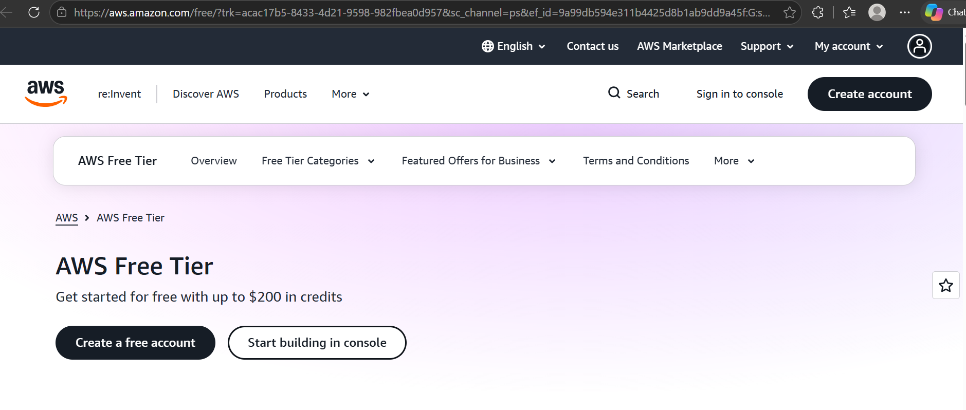
- Sign in to the AWS account using the root user credentials.
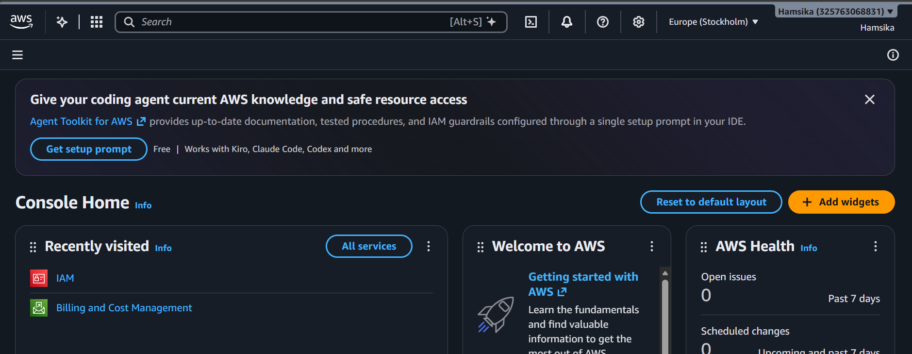
- In the AWS Management Console search bar, type IAM and select Identity and Access Management (IAM).
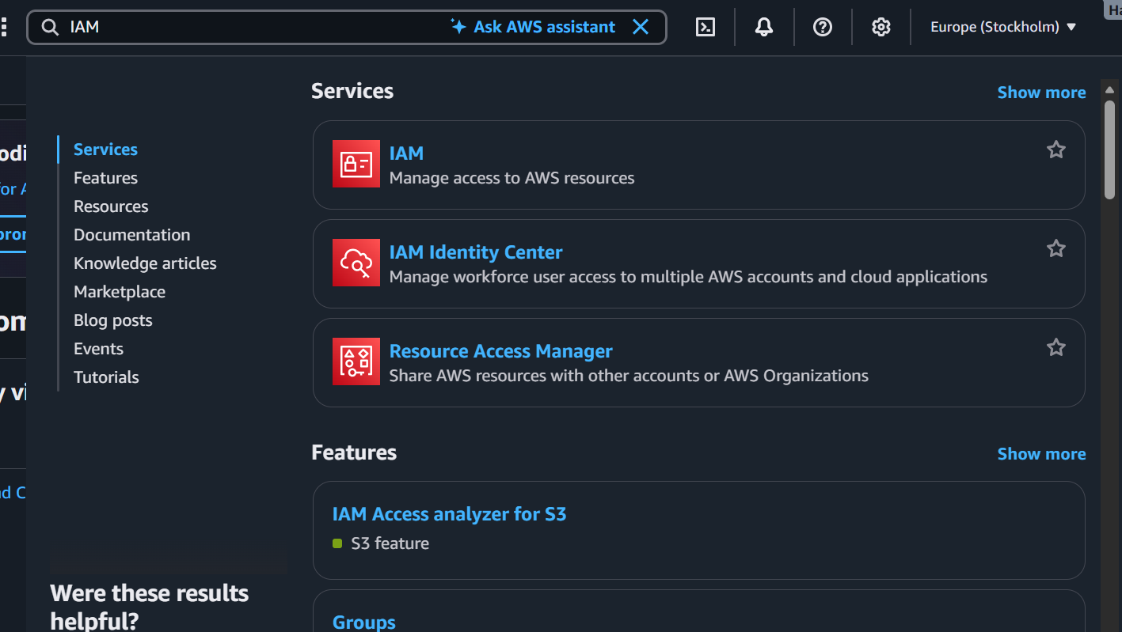
- From the left navigation pane, select Users.
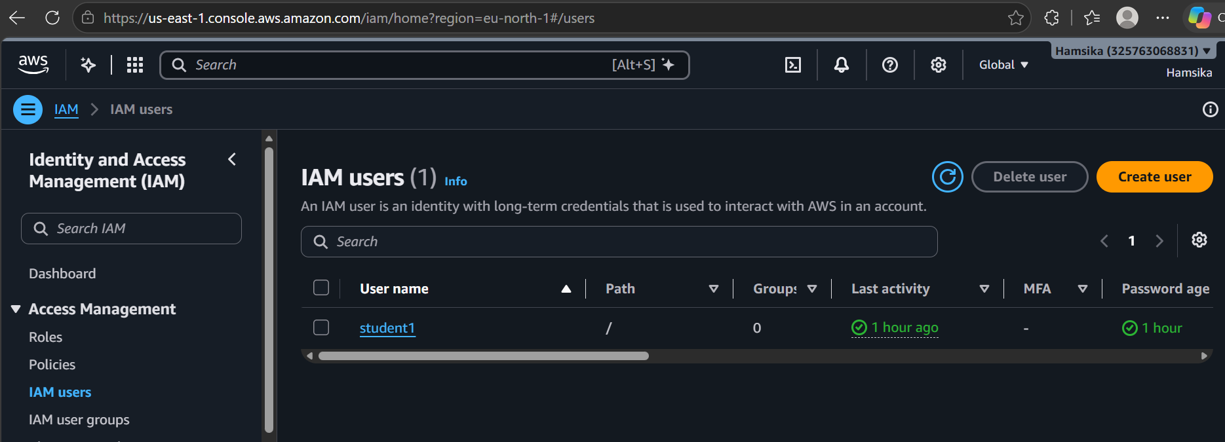
- Click Create user.
- Enter a username (e.g., StudentUser01).
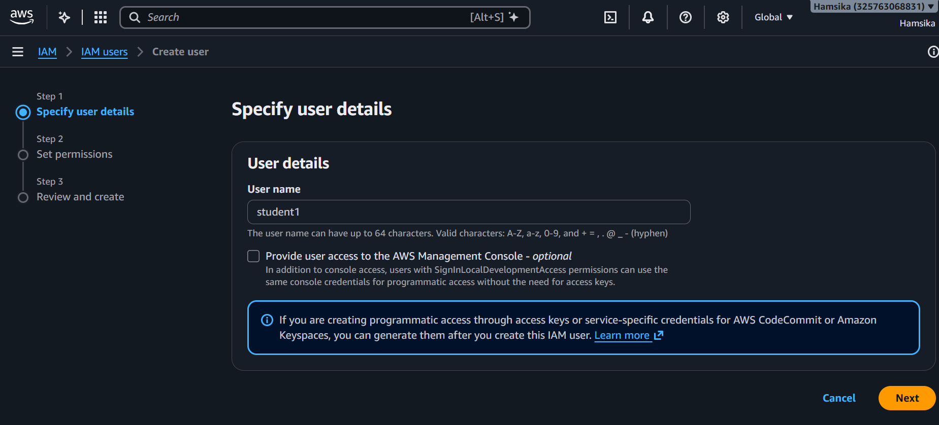
- If the console provides an option to enable console access, select Provide user access to the AWS Management Console.
- Set a custom password or allow AWS to generate a password (Autogenerated password.)
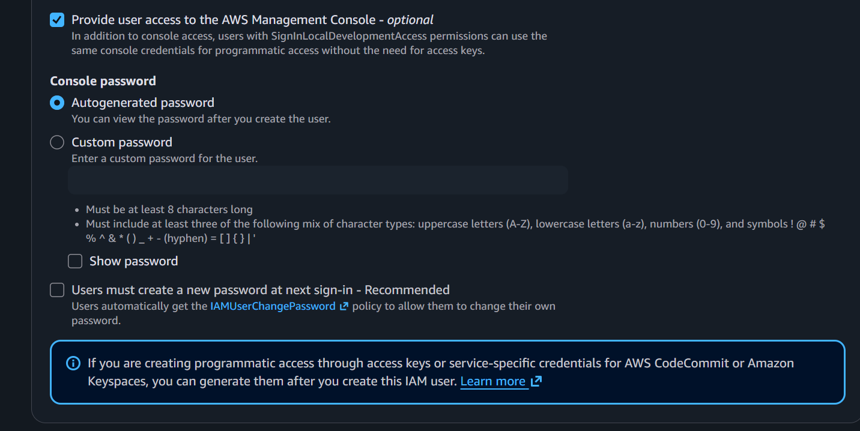
- Select the option requiring the user to create a new password at the next sign-in, if appropriate. (If required you can opt). Click Next.
- Under Set permissions, select Attach policies directly.
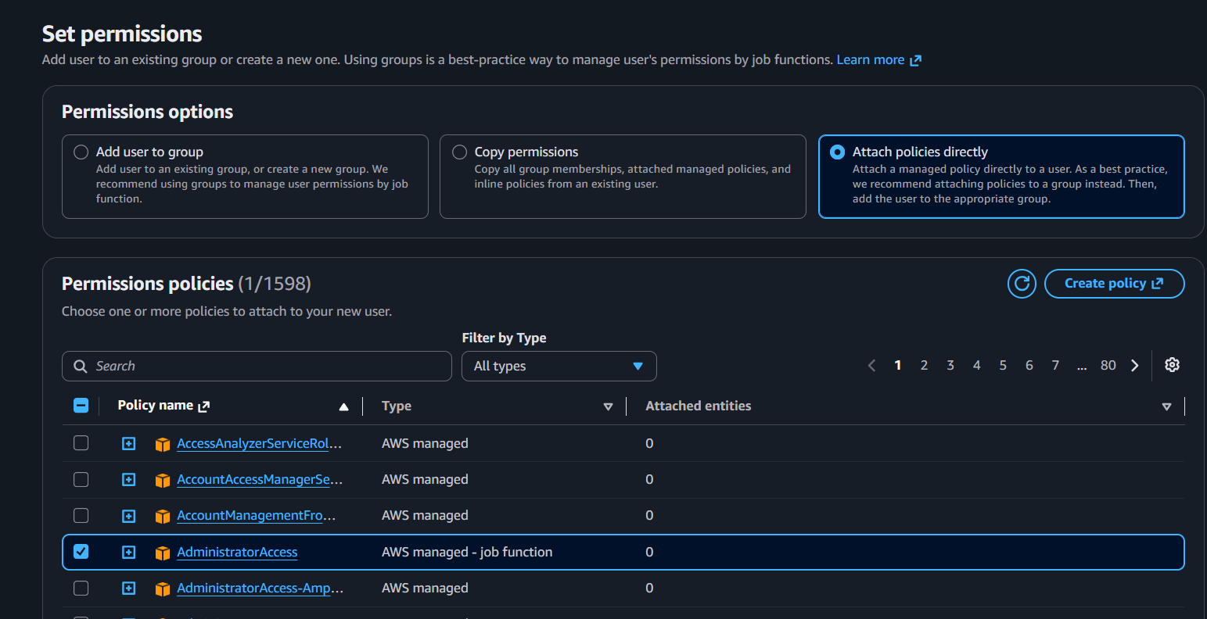
- Select AdministratorAccess - AWS managed - job functionunder policy name and type. Click Next.
- Review the username and permission details.
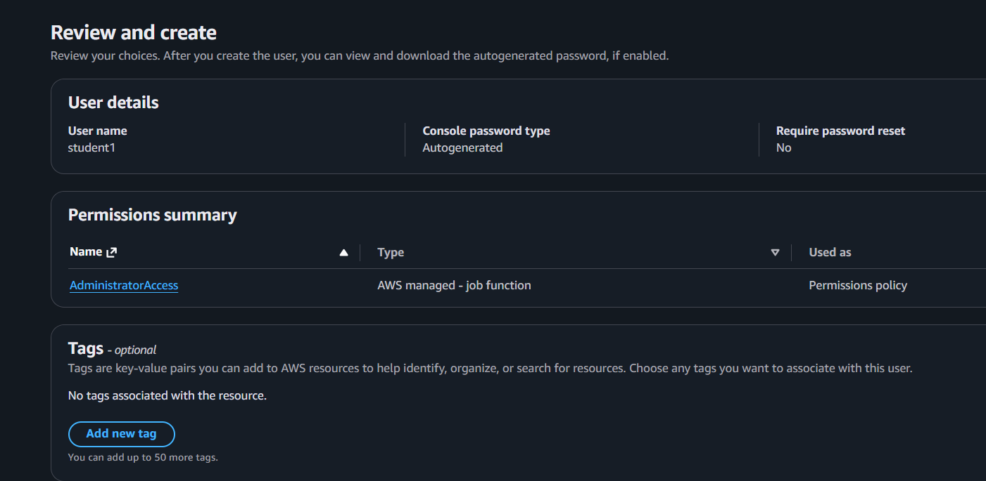
- Click Create user.
- Note down the IAM user sign-in details and securely save the generated password, if applicable.
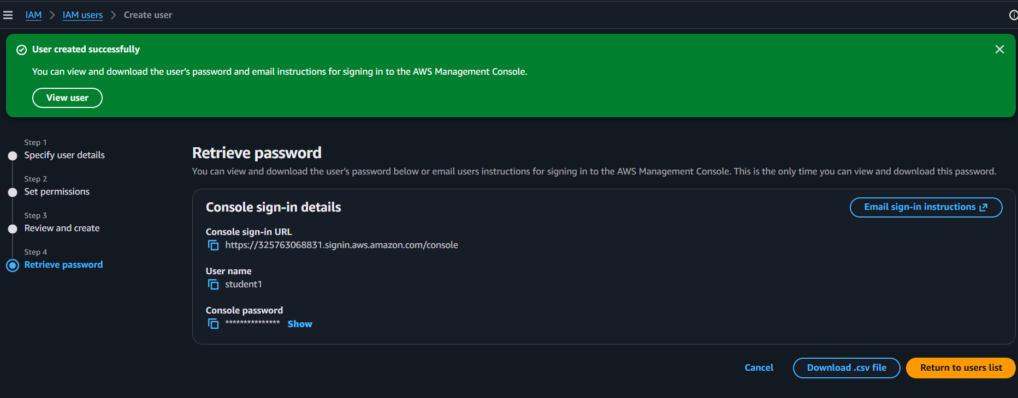
- You can view to see the created IAM user when you click Return to user.
- Sign out of the root account.
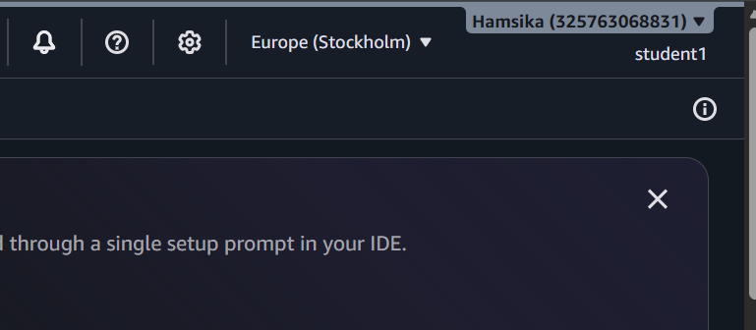

Part B: Enabling Multi-Factor Authentication (MFA)
- Sign in to the AWS Management Console using the IAM user credentials.
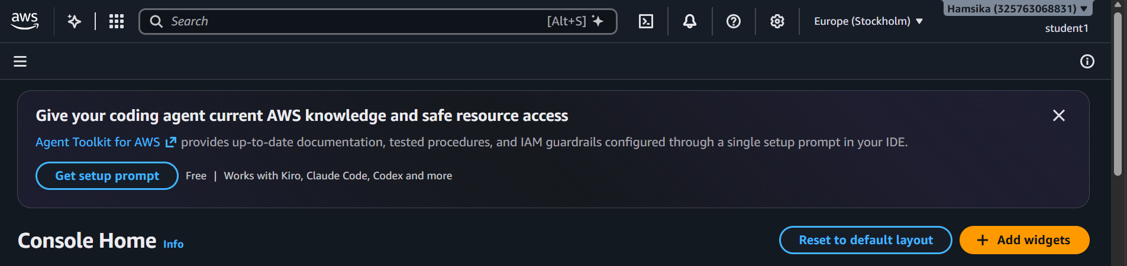
- Search for IAM in the AWS Management Console search bar.
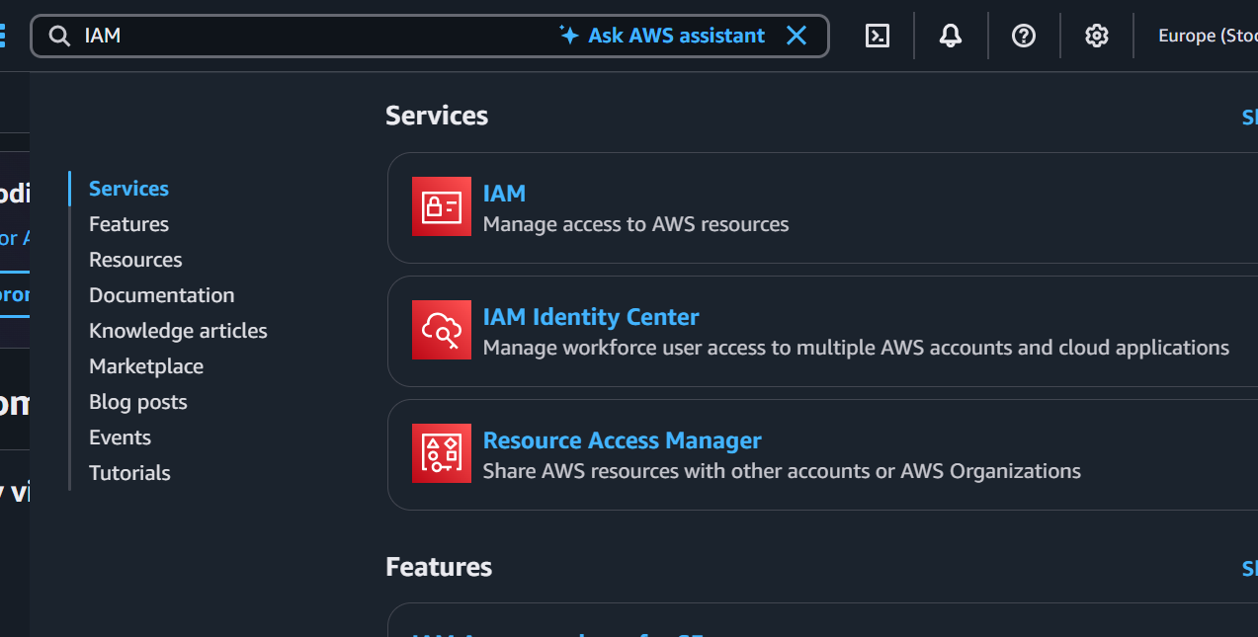
- Open the IAM dashboard.
- From the left navigation pane, select Users.
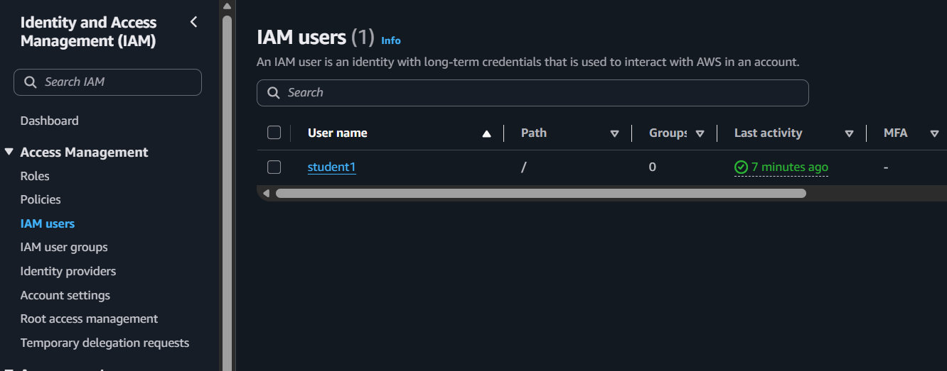
- Click the newly created IAM username.
- Open the Security credentials tab.
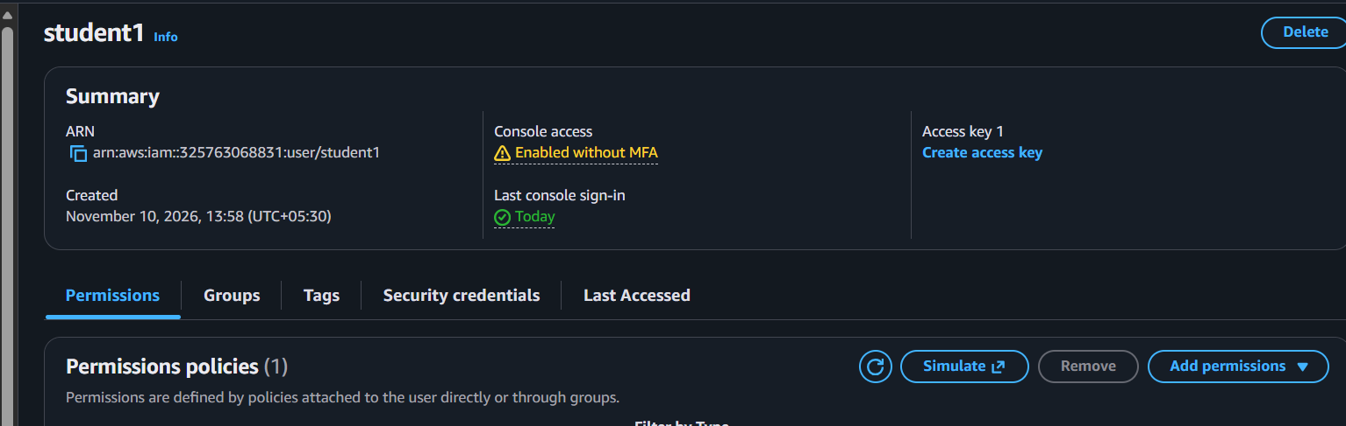
- Locate the Multi-Factor Authentication (MFA) section.
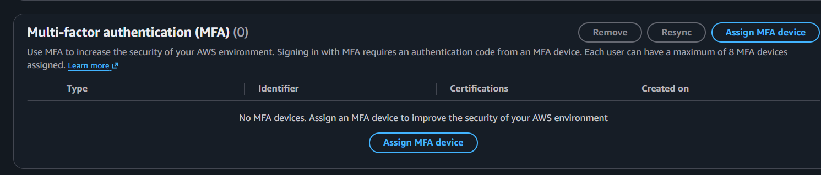
- Click Assign MFA device.
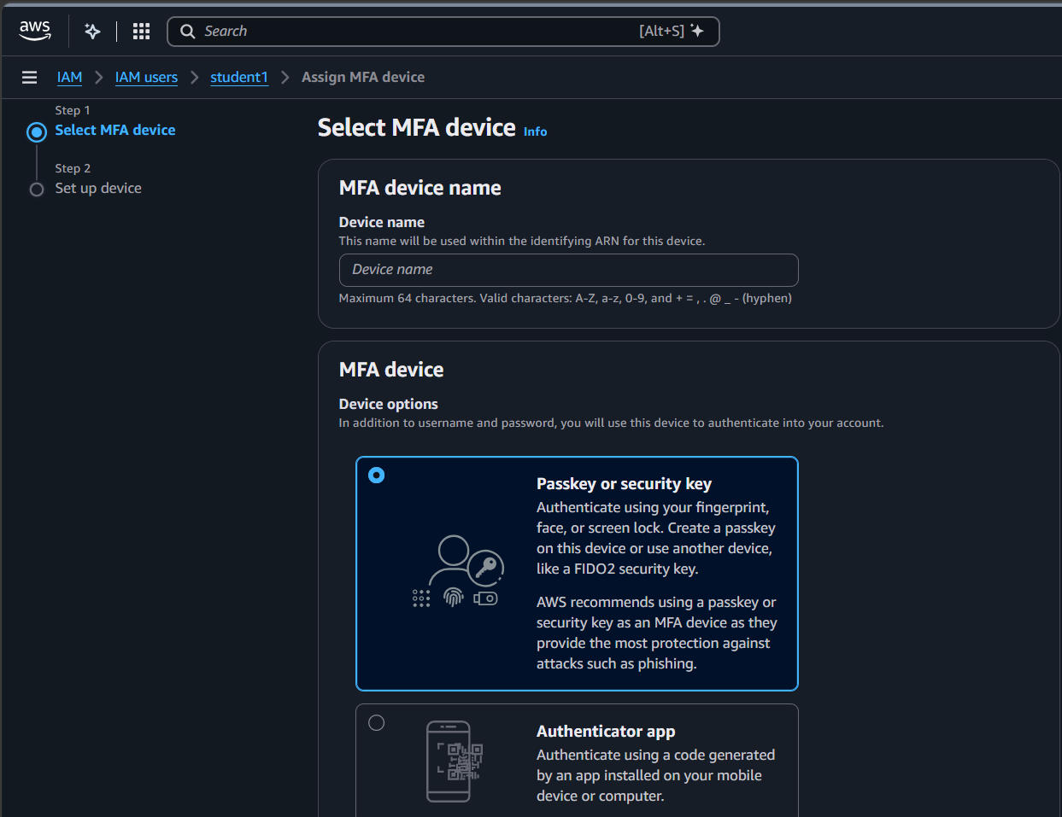
- Enter a device name (e.g., StudentMFA01).
- Select the MFA device type:
  - Passkey or Security key
  - Authenticator app (Google Authenticator or Microsoft Authenticator).

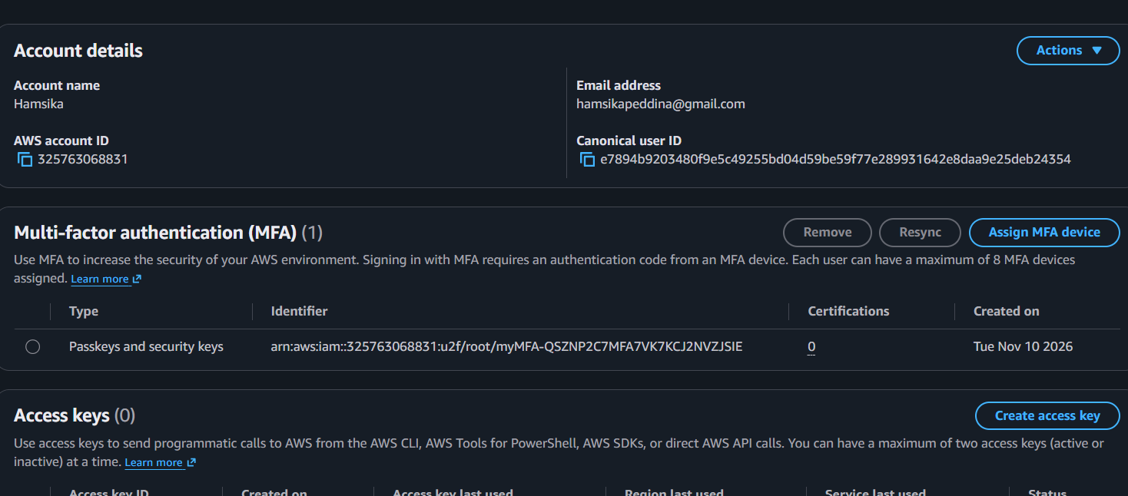

Output:
- An IAM user is successfully created in AWS.
- Appropriate permissions are assigned to the IAM user.
- Multi-Factor Authentication is successfully enabled for the IAM user.
- The IAM user can securely access the AWS Management Console using the configured MFA method.

